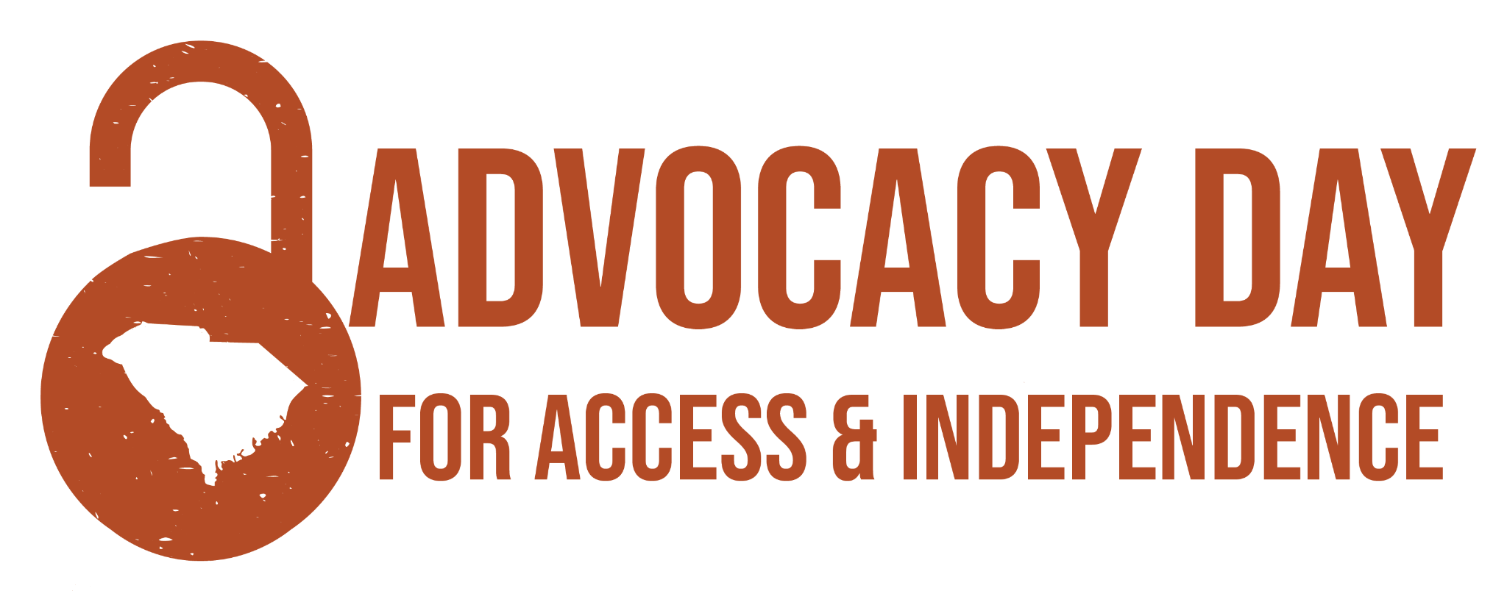 EVENT PARKING DETAILS
We have 202 parking spaces reserved for the event, thanks to the City of Columbia Office of Parking Services. These areas do not require any pass to use the free parking at bagged meters during the event. The reserved parking areas are as follows:

From West to East:
- North and Southbound Assembly St. between Gervais and Pendleton (1100 & 1000 Assembly and Islands)- General event parking at bagged meters free .
- Northbound Sumter St. (1100 & 1000 Sumter) - General event parking at bagged meters free
- Senate St. Eastbound from Sumter St.(1300 Senate and Island) - Van Accessible parking at bagged meters free .
- Senate St. Westbound from Marion St. (1000 Marion) - Accessible Parking free with parking pass
- North and Southbound Marion St. - General event parking at bagged meters free

Special note about Park St. Garage (1007 Park St.):
- Accessible parking is free with your accessible parking placard/plate.
- There is a cost for general parking in this garage.

Accessible Shuttle:
- We will have an accessible shuttle starting at 9:15am running until 10:45am. that will take passengers from the parking garage to the event area.
- The shuttle will also drive a route around our other parking areas should you need assistance getting to the event space.
- There will be a shuttle sign in the front passenger window and on the dashboard of the van, visible from the outside.

